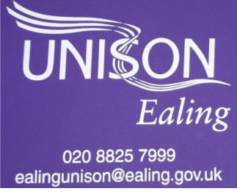
To all Ealing Council Cabinet Members and Ealing MPs

Ealing Unison
Perceval House
4th Floor
W5 2HL
14.06.2022
R:E NJC 2022 Pay Claim for those on NJC Pay
Dear Cabinet Members and MPs,
I hope this finds you well.
As you will be aware, the Joint Unions UNISON, Unite and GMB submitted our 2022 Pay claim to the NJC Employers side on 6th June 2022.
You will receive letters from our Regional and National Unison colleagues, but we wanted to write to you on a local level to explain why we have made this claim, as well as to ask for you to support this claim. Our members are angry; Enough is enough and we need more. Here are the key aspects of our 2022 pay claim:
- A substantial increase with a minimum of £2,000 or the current rate of RPI -
whichever is greater - on all spinal column points.
- A Covid-19 recognition payment
- A national minimum agreement on homeworking policies for all councils and
the introduction of a home working allowance
- An urgent review of all mileage rates currently applying
- A review and update of NJC terms for family leave and pay
- A review of term time only contracts and consideration of retainers
- Reduction in the working week (without loss of pay) to 35 hours (34 in London)
plus one additional day of annual leave
You can view the full pay claim, complete with supporting evidence and research, here.
NJC pay claim 2022-2023 - 6 June 2022.pdf
We are experiencing the worst cost of living crisis since the 1950s. Since January of this year, Many food items have increased on average 20%, petrol 21% and energy bills 54 %. The latter are set to rise a further 50% in October. Come this Autumn, 40% of people across the UK will fall in to fuel poverty. The UK economy has shrunk by 0.3% in the months up to April 2022. As of June 2022, RPI stands at 11.1% and is expected to rise further still.
Ealing Council employees continue to work tirelessly to maintain vital public services and respond to the challenges of covid and this cost of living crisis, often putting the needs of the residents and colleagues they support above their own health and safety. This needs to be recognised not just with words but with a fair and deserved pay rise. As our employer, you can be on our side and add your voice to our calls.
For 10 of the last 11 years, NJC pay awards have fallen below average pay awards across the economy. The value of Local Government and School support staff pay was on average 27.5% lower than it was in 2010 at the Start of 2022. In the last 6 months we have seen the value of LG pay decrease by a further 11% given the rise in inflation and horrendous mismanagement of the economy by the current Government. In effect, this means members are working more than a day and a half a week for free compared to 2010!
Over the coming weeks, we will be contacting members in a range of different ways. We would like to ask for your support and flexibility in arranging Unison meetings across Council workplaces and communicating with members in every way we can to explain why this pay claim is so important and support our members in and spreading the word to others. Thank you in advance for your support in this endeavour.
As a Labour Cabinet, we seek and expect your public and behind the scenes support for our 2022 pay claim and campaign for a fair pay rise. Will you join other Labour Local Authorities in publicly supporting our call for a fair pay rise?
The LGA are starting to consult employers this month; please tell them that you strongly support our claim and urge them to feed these views back to the NCJ employers side.
Will you write to staff directly to say you think they should receive £2,000 or RPI, whichever is greater? Will you write to Ealing Schools to urge them to support our pay claim? Will you pledge to support Unison and sister Trade Unions in achieving a better pay rise for our members?
Higher wages benefit our members, the Council and your residents through recruitment, retention, and job satisfaction as well as stimulating the local economy. Fundamentally though, all employees deserve a fair days work for a fair days pay; given that local government employees earn 27.5% less than we did in 2010 (with the figure set to double by 2023), this is not the case for public sector employees at the moment. We want to change that.
You can view our campaign hub here- We Need More | Campaigns | UNISON National
We look forward to hearing from you and continuing to work with you for the benefit of our members and your residents. Please do respond to us as a matter of urgency.

Yours Sincerely,
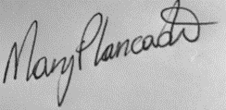

Sukhminder Kalsi Mary Lancaster
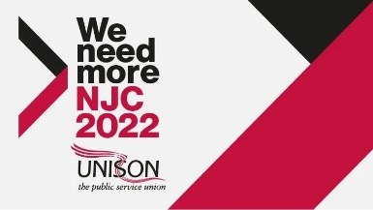
Branch Chair Branch Secretary Ealing Ealing Unison Ealing Unison

